**LAB # 03**

**Task 1: Create basic calculator application on Console Application that perform basic arithmetic operations like(add,subtract,multiply,divide ….)**

**Solution :**

internal class Program

{

static void Main(string[] args)

{

int a = 0, b= 0;

Console.Write("What would you like to perform ?\n" +

"1) Addition\n2) Subtraction\n3) Multiplication\n4) Division\n5) Exit\n" +

"\tSelect any One : ");

int choice = int.Parse(Console.ReadLine());

if (choice == 5) System.Environment.Exit(0);

input(ref a, ref b);

switch (choice)

{

case 1:

Console.WriteLine($"\nAddition of {a} and {b} is = {add(a,b)}\n");

break;

case 2:

Console.WriteLine($"\nSubtraction of {a} and {b} is = {sub(a, b)}\n");

break;

case 3:

Console.WriteLine($"\nMultiplication of {a} and {b} is = {mul(a, b)}\n");

break;

case 4:

Console.WriteLine($"\nDivision of {a} and {b} is = {div(a, b):0.##}\n");

break;

default:

Console.WriteLine("\n\tInvalid Choice : Try Again\n");

break;

}

Main(args);

}

static void input(ref int a, ref int b)

{

Console.Write("\nEnter number 1 = ");

a = int.Parse(Console.ReadLine());

Console.Write("Enter number 2 = ");

b = int.Parse(Console.ReadLine());

}

static int add(int a,int b) {

return a + b;

}

static int sub(int a,int b) {

return a - b;

}

static int mul(int a,int b) {

return a * b;

}

static double div(int a, int b) {

return (Double)a / b ;

}

}

**OUTPUT :**

**Task 2 : Create Winform application that authenticate user with hardcoded username and password if user authenticated new form will be open that takes user information as an input and on button click all information will be displayed in dialog box.**

**Solution :**

**Form 1 (Authentication)**

public partial class Form1 : Form

{

string uName = "Junaid";

string pass = "0000";

public Form1() {

InitializeComponent();

}

private void button1_Click(object sender, EventArgs e)

{

if(uName == User_textBox.Text && pass == pas_textBox.Text)

{

//wrong.Visible = false;

Form2 obj = new Form2();

obj.Show();

}

else

wrong.Visible = true;

}

}

**Form 2 (User Information)**

public partial class Form2 : Form

{

public Form2()

{

InitializeComponent();

}

private void button1_Click(object sender, EventArgs e)

{

MessageBox.Show($"Your Father Name is {fname.Text}\nYour Age is

{age.Text}\nYour School Name is {school.Text} \nYour Address is {address.Text}",

"Details", MessageBoxButtons.OK, MessageBoxIcon.Information);

}

}

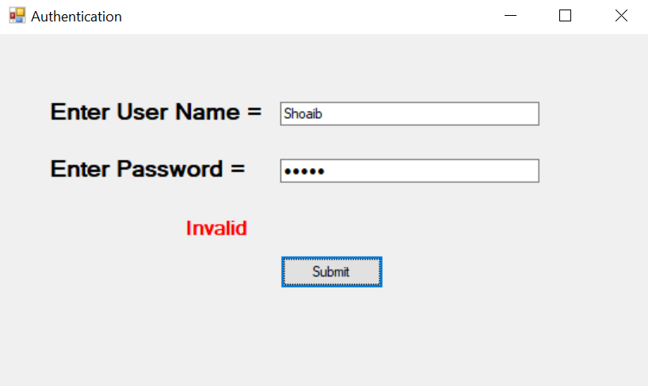**OUTPUT :**

